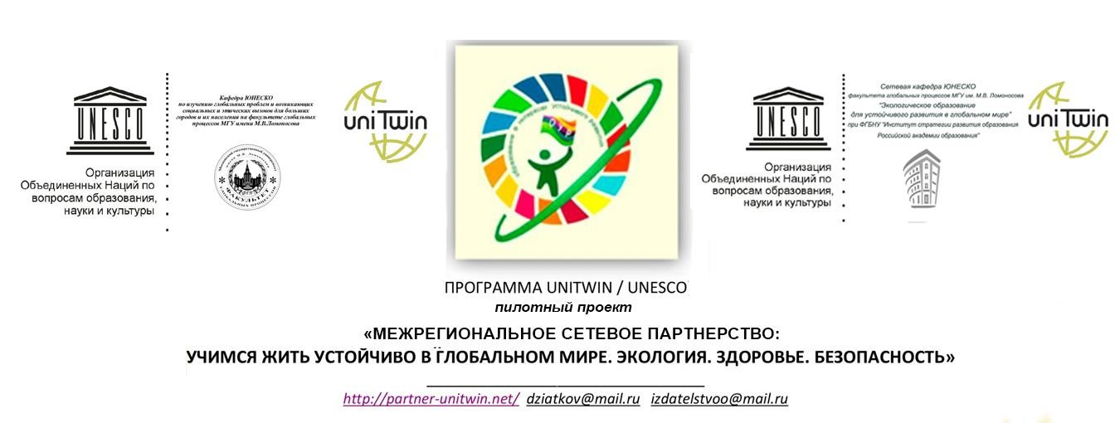

ПОЛОЖЕНИЕ

О КОНКУРСЕ ВИДЕОРОЛИКОВ НА АНГЛИЙСКОМ ЯЗЫКЕ

THE REGULATION ON VIDEOS COMPETITION IN ENGLISH

«Поговорим о целях устойчивого развития»
«Give a talk about Sustainable Development Goals»

Dear participants of the competition!

In 2015, countries adopted the 2030 Agenda for Sustainable Development and its 17 Sustainable Development Goals.
What is sustainable development?
- Sustainable development has been defined as development that meets the needs of the present without compromising the ability of future generations to meet their own needs.
- Sustainable development requires concerted efforts to build an inclusive, sustainable and viable future for people and the planet.
- For sustainable development to be achieved, it is crucial to harmonize three core elements: economic growth, social inclusion and environmental protection. These elements are interconnected and all are crucial for the well-being of individuals and societies.
The Sustainable Development Goals are the blueprint to achieve a better and more sustainable future for all. They address the global challenges we face, including those related to poverty, inequality, climate, environmental degradation, prosperity, and peace and justice. The Goals are interconnected, it ís important that we achieve them by 2030.

The Sustainable Development Goals are a call for action by all countries – poor, rich and middle-income – to promote prosperity while protecting the planet.
We invite you to get acquainted with the goals of sustainable development, to reflect on your role and contribution to the prosperity of our planet.
Our competition is dedicated to the study and development of 17 UN goals in the field of sustainable development, which are presented on the website https://www.un.org/sustainabledevelopment/ru/sustainable-development-goals/.

The aim of our competition is to promote understanding of the goals of sustainable development by children and adults, the ability to express their understanding in English, the dissemination of knowledge in their environment. Participants are invited to prepare a video plot that reflects an understanding of all or one of the 17 goals of sustainable development.

Regulation
on the Interregional videos competition in English for students
“Give a talk about sustainable development goals”

1. General provisions
1.1 Interregional competition of videos in English for students of educational organizations “Give a talk about sustainable development goals” is organized by
- municipal budgetary institution of supplementary professional education “CEDP”, Angarsk, Irkutsk region;
- municipal autonomous institution of supplementary professional education “CED”, Bratsk;
- municipal autonomous institution information and methodology centre of Tomsk.
With the support of the UNESCO Network Chair “Environmental Education for Sustainable Development in the Global World” at the Federal State budgetary institution “Education Development strategy of the Russian Academy of Education”, “Interregional Network Partnership: Learn to live sustainably n a global world.” Ecology. Health. Security”. (UNITWIN/UNESCO program)
1.2 The competition is aimed at introducing students to the goals of sustainable development and disseminating the knowledge gained among peers and others. The competition involves a meaningful understanding of all, few or one of the 17 goals of sustainable development and the presentation of one’s own opinion in English.
1.3 The result of the competition will be an exhibition of EXPO videos, which will be posted on the website of the competition organizers http://partner-unitwin.net/.
2. Purpose of competition
Creation of conditions for understanding the sustainable development goals, dissemination of knowledge and presentation of one’s own position in English.
3. Competition tasks
3.1. To introduce the participants to the 17 sustainable development goals.
3.2. To draw attention to the ideas of sustainable development.
3.3. To increase the language competence level.
3.4. To organize the exhibition of EXPO videos on the website of the competition organizers http://partner-unitwin.net/.
4. Participants of competition
4.1. The participants of the competition are students of educational organizations aged 14 years (grades 8-11).
5. Organization of competition
5.1. The organizing Committee (the jury) organizes and conducts the competition.
5.2. The organizing Committee ensures equal conditions, objectivity of evaluation of all videos submitted by participants to the competition.
5.3. The organizing Committee and the jury consists of methodologists of the municipal autonomous institution information and methodology center of Tomsk, municipal budgetary institution of supplementary professional education “CEDP”, Angarsk, Irkutsk region, municipal autonomous institution of supplementary professional education “CED”, Bratsk; highly qualified teachers.
5.4. The jury evaluates the competition materials, determines the winners and prize-winners in accordance with this Regulation.
6. Competition requirements
6.1. To participate in the competition, students need to familiarize themselves with the sustainable development goals posted on the website https://www.un.org/sustainabledevelopment/ru/sustainable-development-goals/
6.2. Both individual and collective works with the indication of the responsible person are accepted for participation in the competition.
6.3. The following is submitted to the competition:
-the video is in English,
-information map contains data of the participants, the text in Russian, reflecting the understanding of the selected goals of sustainable development (Annex). This text may coincide with the content of the video.It is desirable that the text was not borrowed from the Internet, had a personal character and was associated with the cultural heritage of people, folklore images, myths, symbols.
6.4. The number of works from one participant is not limited.
6.5. Participation in the competition is paid (200 rubles per work). In order to participate, it is necessary to fill out a package of documents (contract, application, act of performance of works, application and statement of consent from a person) and pay a receipt (Annex 2). Documents should be filled out only with blue ink pen without putting down dates.
A copy of the receipt and the originals of all completed documents (contract, application, act of performance of works, application and statement of consent from a person) should be sent by mail to the address: 634041, Tomsk, Kievskaya str., 89, MAI information and methodology center of Tomsk
Please note that without the original documents and receipt of payment work on the competition is not accepted.
Algorithm for participants from other regions
Step 1. Download and fill in the documents (contract, act, application and consent to the processing of personal data, receipt for payment) with BLUE paste, without putting down dates, without allowing corrections. Documents are issued for each participant of the Competition.
Step 2. Scan the receipt of payment, send the application form to the following e-mail address: imc@obr.admin.tomsk.ru marked " video Competition»
Step 3. Attach a copy of the payment receipt and send the originals of all completed documents (contract, act, application and consent to the processing of personal data) by mail to: 634041, Tomsk, Kievskaya str. 89, MAI information and methodology center of Tomsk.
6.6. The competition is held in correspondence.
6.7. Participants send their videos and applications to participate in the contest by e-mail: imc@obr.admin.tomsk.ru (obligatory indication in the subject line " Video competition in English").
Application form:
Full Name of the participant (s)
Name of the institution (full, abbreviated)
Name (in full) of the accompanying participant, position
Contact phone number
Email address
The name of the video
Number of works

7. Technical requirements of the competition
Videos shot (created) by any available means corresponding to the subject of the contest are provided for the contest.
Requirements for video clips:
7.1. Video format: DVD, MPEG4.
7.2. The minimum video resolution is 720x480 (12: 8 cm).
7.3. The duration of the video is up to 60 seconds.
7.4. Videos should be decorated with information splash-titles (goal UR, Fi contestant (s), the full name of the institution, the region)
7.5. The use of special programs and tools during the installation and shooting of the video is at the discretion of the participant.
7.6. Participants themselves determine the genre of the video (interview, report, video clip, cartoon, etc.).
7.7. The video is voiced in English
7.8. The competition does not accept commercials of an advertising nature that offend the dignity and feelings of other people, do not fit into the theme of the competition.
8. Copyright
The participant (team of participants), who sent the work to the competition, is responsible for compliance with the copyright of the work participating in the competition.
9. Evaluation criteria of competitive materials
The jury gives an assessment of the videos, which is carried out according to the following criteria:
Evaluation criterion | points
Correspondence of the content of the work to the stated purpose of the Sustainable Development | 0-10
Informative (logical construction of the text, the absence of inaccurate information, the presence of the author's position in relation to the purpose of SD) | 0-30
Quality of language support (literacy, lexical saturation, pronunciation) | 0-30
The visual quality of the video | 0-10
Creativity of the video (novelty, originality of material presentation) | 0-20
The maximum rating of the contest work is 100 points.
10. Terms and procedure of the competition
10.1. Acceptance of competitive works is carried out from 01.12.2019 to 01.02.2020 (inclusive). Works received after the specified period are not considered by the competition jury.
10.2. The results of the competition are posted on the websites of the competition organizers no later than 20.03.2020.
11. Rewarding
11.1. Winners and prize-winners of the competition are awarded with diplomas.
11.2. A certificate confirming participation in the competition is issued to its participant.
11.3. Participants from other regions receive scans of award documents.

